Union and Sutherland’s River Presbyterian Churches Thorburn and Sutherland’s River, NS

Modelling faith in our communities one conversation at a time
Inside this issue:
Change and Adjustment 2
A Bit of History 2
As I Remember 2
Recipes 3
Sunday School 3
Varia 3
Photos 3
Calendar 4

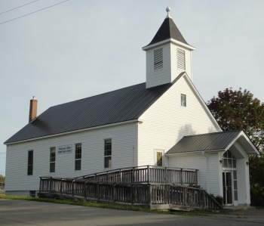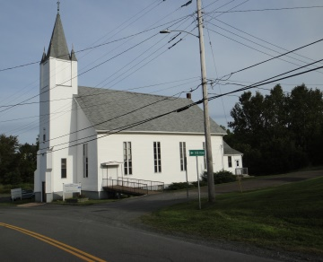
Sutherland’s River Thorburn

Minister’s Reflection (Rev. Dickson)
One day Satan and Jesus were having a conversation. Satan had just come from the Garden of Eden, and he was gloating and boasting. "Yes, sir, I just caught the world full of people down there. Set me a trap and used bait I knew they couldn't resist and I got 'em all!” “What are you going to do with them?" Jesus asked. Satan replied, "Oh, I'm gonna have fun! I'm gonna teach them how to marry and divorce each other, how to hate and abuse each other, how to drink and smoke and curse. I'm gonna teach them how to invent guns and bombs and kill each other. I'm really gonna have fun!" "And what will you do when you get done with them?” Jesus asked. "Oh, I'll kill 'em," Satan glared proudly. "How much do you want for them?" Jesus asked. "Oh, you don't want those people. They ain't no good. Why, you'll take them and they'll just hate you. They'll spit on you, curse you and kill you!! You don't want those people!!" "How much?" He asked again. Satan looked at Jesus and sneered, "All your tears, and all your blood.” Jesus said, "DONE!" Then He paid the price…. So here are a few questions (actually, just one…):Isn't it funny how simple it is for people to trash God and then wonder why the world's going to hell? Isn't it funny how we believe what the newspapers say, but question what the Bible says? Isn't it funny how everyone wants to go to heaven provided they do not have to believe, think, say, or do anything the Bible says? Isn't it funny how the lewd, crude, vulgar and obscene pass freely through cyberspace, but the public discussion of Jesus is suppressed in the school and workplace? Isn't it funny how someone can be so fired up for Christ on Sunday, but be an invisible Christian the rest of the week? Isn't it funny how we can be more worried about what other people think of us than what God thinks?
Are you laughing yet?

CONTACT INFORMATION
Interim Moderator: Greg Dickson 902-759-8221
Clerk of Session (Thorburn): Ray Kirk 902-922-2526
Clerk of Session (Sutherland’s River): Audrey Hodder 902-922-2379
Board of Managers (Thorburn): Jane Taylor 902-755-4408
Treasurer (Thorburn): Kathy Campbell 902-759-1705

Volume 2, Issue 1
January 1st, 2018
BIMONTHLY NEWSLETTER
JANUARY/FEBRUARY NEWSLETTER
page 2
Change and Adjustment – Who Knew?

The first article I wrote for our newsletter was about change, adjustment and the need to carry on. Little did I know how quickly things here in our congregations could change? We are beginning a new year without a fulltime minister, a difficult task, but we can handle it. We continue to mourn the death of one of our congregation’s much-loved ladies, Barbara Palmer. Three members here in Thorburn have undergone surgeries from which they are recovering. How quickly our lives can change. In mid-November, while returning home from visiting my sister near Bridgewater, I was involved in a car accident. I received a serious back injury. After spending three weeks in the hospital, I am now convalescing at my sister’s and I am getting stronger every day. How quickly our lives can change but we learn to adapt and persevere. In hindsight, perhaps I should have chosen a different topic for the first article I wrote for our newsletter about change and adjustment. However, life happens and we do adjust. As we enter a new year, I leave you with this excerpt from a recent issue of the AMS magazine:
“Accept the surprises that upset your plans, destroy your dreams, give your day a different content and perhaps even your life. It is not coincidence. Give the Lord freedom so that he alone can command your days.”
Gail Jordan

B i A Bit of History From Union Church 100 Years Ago

As I Remember (by Evelyn McKay)

The Kirk Session of Union Church met in the vestry on January 13th, 1918 and was constituted with prayer by the moderator, Rev. J.A. Stead Burns. Elders present were James H. Fraser, Wm. A. Fraser, D.A. Johnson, Harry Powell and James MacLean. Purpose of the meeting was to prepare for a Communion Service in Union Church on January 27th, 1918, at which time F. Pryour Meikle and Dan G. MacDonald would be ordained as Ruling Elders of Union Church.
Gerald MacLellan

Shortly after I came, the Young Peoples’ Society (YPS) were planning their yearly play. The YPS invited Viola Johnstone, Burns MacDonald, Mary MacLean and me, to take some parts in their play. Mary is from Hopewell, and was teaching in the old school across from the church, where the fire hall now stands. One afternoon we had to have an extra practice because we were invited to put the play on in another church. I was asked to go across the road and ask Mary if she would dismiss her class an hour early, because we really needed her for practice. NO WAY! Mary would not dismiss her class early. Students were required to be in school a certain number of hours a day and Mary was sticking to the rules.
I remember Howard Mason and Bain McKay were stage hands, and were responsible for the lighting and putting up the stage props.
After the play was presented in our own church, the cast was always invited to perform it again in other churches. A small fee was charged and the money was divided between the two churches. This was how the YPS made their money. Plays were very popular at that time. Mrs. Jimmy Harvey Fraser always directed the plays. There is a picture of the cast of this play in the case at the back of the church sanctuary.
(to be continued next issue)

page 3
JANUARY/FEBRUARY NEWSLETTER

Recipes

Kool-Aid Jelly (may use strawberry, raspberry, cherry or grape)
Save 2 cups of juice from boiled beets, add 1 pkg. Certo crystals and boil 1 minute. Add 4 cups white sugar and boil 6 minutes. Remove from heat and add 1 pkg. Kool-Aid. Skim and bottle.
Josie Butler

Sunday School Registration

Registration for Sunday School at Union Presbyterian Church in Thorburn will be on January 7th between 10:45 and 11:45 am in the church basement. The program is open to all children and our purpose is to help young people develop their love of God, good values and faith to support them in times of difficulty. We will develop student leadership through teamwork, crafts, music, bible stories and special projects. Classes will begin Sunday, January 14th at 10:45 to 12:00 noon. Please contact Darlene Reeves at 902-922-2666 if you are not available to register your child on this date or if you have any questions.

Varia

If anyone would like to receive this newsletter by email please contact Gail Jordan or John Reeves.
This is a link to a great Daily Devotional website: http://www.presbycan.ca/
The website for the church can be found at: http://pccweb.ca/union-thorburn/
You can also follow us on Facebook

Photos

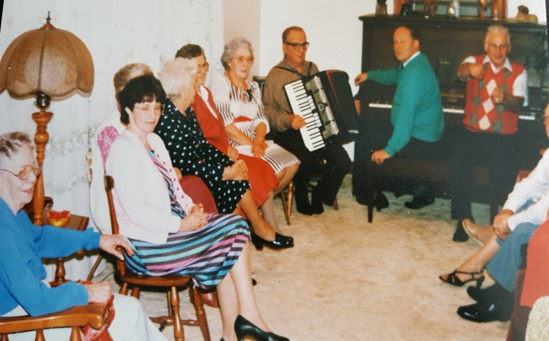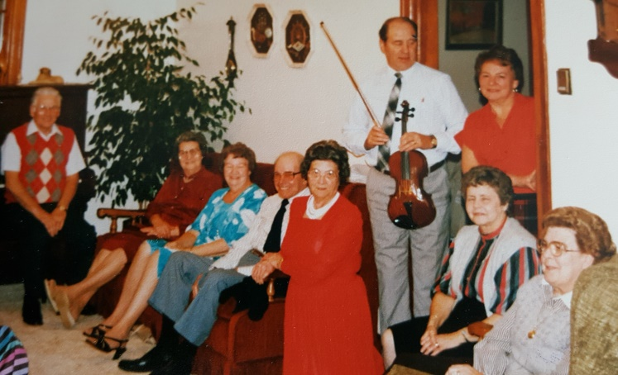
Choir practice at Laura Dempster’s

 | January 2018
Sun | Mon | Tue | Wed | Thu | Fri | Sat
 | 1  Happy New  Year! | 2 | 3 | 4 | 5 | 6
7 Services:  9:30: Sutherland’s River  11:00: Thorburn  10:45: Sunday School Registration | 8 | 9 | 10 | 11 | 12 | 13
14  Services:  9:30: Sutherland’s River  11:00: Thorburn  10:45: Sunday School | 15 | 16 | 17 | 18 | 19 | 20
21  Services:  9:30: Sutherland’s River  11:00: Thorburn  10:45: Sunday School | 22 | 23 | 24 | 25  11:00:Community Soup Lunch | 26 | 27
28  Services:  9:30: Sutherland’s River  11:00: Thorburn  10:45: Sunday School | 29 | 30 | 31  10:30:Cradle Roll | May the new year bring you lots of blessings and joy!
JANUARY/FEBRUARY NEWSLETTER

page 4
 | February 2018
Sun | Mon | Tue | Wed | Thu | Fri | Sat
 |  |  |  | 1 | 2 | 3
4 Services:  9:30: Sutherland’s River  11:00: Thorburn  10:45: Sunday School | 5 | 6 | 7 | 8 | 9 | 10
11  Services:  9:30: Sutherland’s River  11:00: Thorburn  10:45: Sunday School | 12 | 13 | 14  Happy Valentine’s  Day! | 15 | 16 | 17
18  Services:  9:30: Sutherland’s River  11:00: Thorburn  10:45: Sunday School | 19 | 20 | 21 | 22  11:00:Community Soup Lunch | 23 | 24
25  Services:  9:30: Sutherland’s River  11:00: Thorburn  10:45: Sunday School | 26 | 27 | 28  10:30:Cradle Roll

